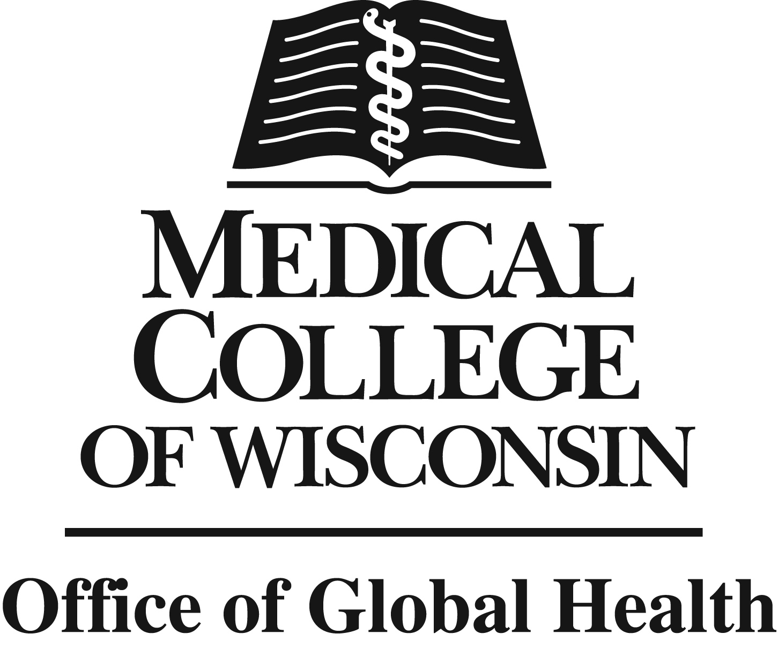
Dr. Elaine Kohler
Summer Academy of Global Health Research

Established in January 2010, the Office of Global Health at the Medical College of Wisconsin (MCW) is a high impact, model office that seeks to be a transforming force in global health through research, education, patient care, and community engagement and addresses health disparities from neighborhoods to nations by partnering with faculty and supporting trainees. Experiences in global health have proven to be invaluable in shaping the interests and careers of students. Medical College of Wisconsin first year medical students (M1s) interested in funding for summer research in global health may apply for this opportunity.

Dr. Elaine Kohler, a MCW alumnus (Pediatrics Fellowship 1968) and former Associate Professor of Pediatrics (1968-1981) is remembered by her medical colleagues and within the community she served with deep respect for her advocacy in the fields of diabetes, obesity, heavy metal toxicity and mental health. She believed in a call to service and worked with passionate dedication to improving the health of children in Milwaukee and Africa. She loved the infectious energy and idealism of youth and generously shared her passion with those who believed in changing the world.

This named summer global health research program is for MCW medical students who seek to recognize Dr. Kohler’s legacy long after her untimely death in 1981. The program pays tribute to her life’s local and global health work by providing support for those projects and individuals who carry on her selfless commitment to helping others.

The Dr. Elaine Kohler Summer Academy of Global Health Research encourages talented MCW medical students to enter the research field during a 10-week hands-on experience. Students spend half the summer addressing global health disparities locally in Milwaukee and the other half internationally. This experience allows students the opportunity to collaborate with faculty to address global health issues such as water, injury prevention, and human molecular genetics. Students will be paired with a faculty member with ongoing research and their global and local partners. Summer placements change annually. Six students are selected and receive a $3,500 stipend for the 10-week program.

All eligible applicants will have their applications reviewed and will be invited to an initial interview. Finalists will be invited to a second interview with the Associate Dean for Global Health who will make the final decision. Selection criteria are:
- Illustrates a genuine enthusiasm and passion for global health
- Past work or volunteer experience in public health or research or projects in diverse-resource settings or with diverse populations domestically or internationally
- Proposed career path will incorporate elements of global health including health inequities and reduced access to health care

Application Process
Along with your resume, complete this application form and submit it with the file name saved as your first and last name to Tifany Frazer electronically at tfrazer@mcw.edu on or before December 3 at midnight (CST). Please do not submit any materials in addition to the application and your resume as they will not be reviewed.
Dr. Elaine Kohler Summer Academy of Global Health Research
Application Form

First Name |  | Last Name
Address
City |  | Zip Code
Phone |  | Email
Pathway | Bioethics  Clinician Educator  Global Health  Health Systems Manage/Policy |  | Physician Scientist: Clinical, Translational  Physician Scientist: Molecular, Cellular  Quality Improvement/Patient Safety  Urban and Community Health
In the space provided below, please explain 1) your past global health experiences; 2) how you will incorporate global health into your future career goals, and 3) how a summer global health research experience will enhance your professional development.

Signature (electronic signature acceptable) | Date
Established 1/2012, Revised 9/2019

