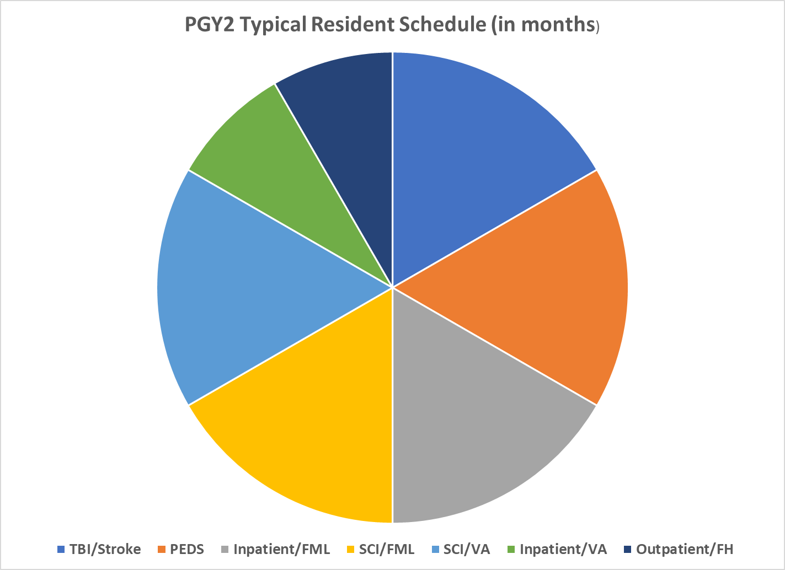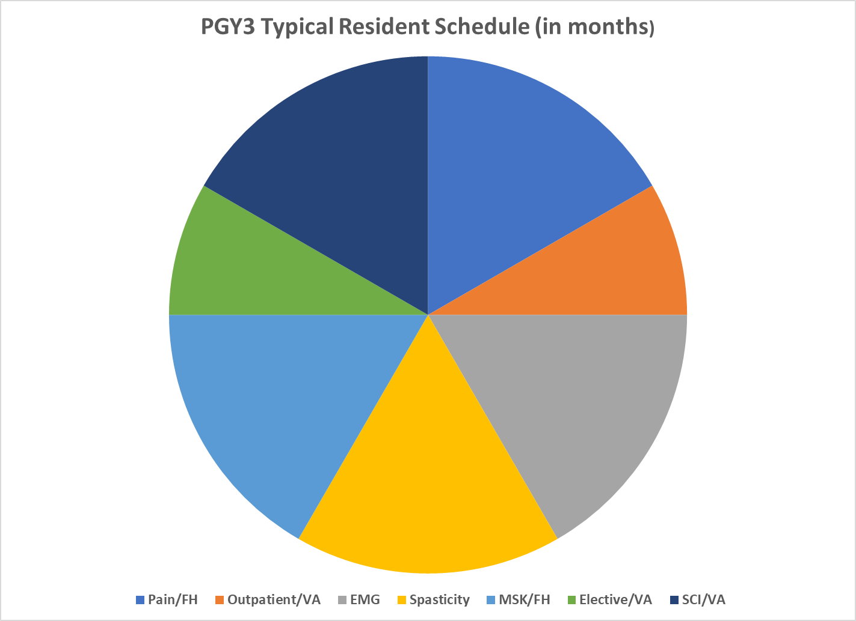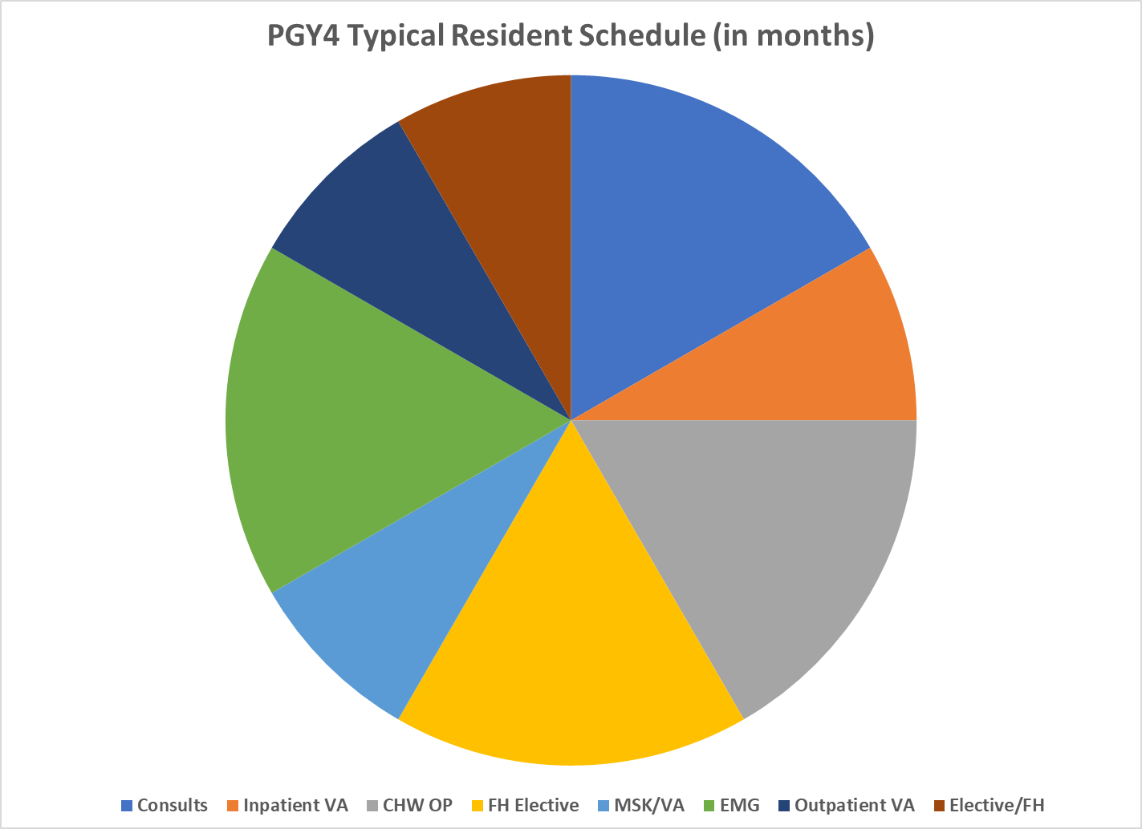

Rotation Name | Brief Description
TBI/Stroke | Provide training and experience in the evaluation and management of patients with neurologic disorders and brain injuries.
PEDS | Provide training and experience in inpatient consultative and outpatient care and service to children and families with brain injuries, cerebral palsy, musculoskeletal injuries, neuromuscular diseases, neurosurgical procedures, myelomeningocele and other disabling disorders of childhood.
Inpatient/FML | Provide training and experience in the evaluation and management of comprehensive inpatient rehabilitation for patients with various diagnoses, including multiple trauma, orthopedic injuries, amputation(s), severe generalized deconditioning and neurologic disorders.
SCI/FML | Provide training in the management of new spinal cord injuries and initial rehabilitation with an interdisciplinary focus that provides consistent coordination and expert care.
SCI/VA | Provide training on acute rehabilitation and sustaining care (primary care) of spinal cord injury/disease veterans of US Armed Forces.
Inpatient/VA | Provide training on physiatric consultation and inpatient rehabilitation care/management to veterans with stroke, amputation, orthopedic/neurologic/cardiopulmonary and other disabling conditions. There are outpatient clinic opportunities in MSK, Spasticity, Prosthetic Limb and Electrodiagnosis.
Outpatient/VA | Provide training and experience in common joint injections.
Elective/FML | Exposure and training in multiple rehab settings at FMLH, chosen by the resident based on their interests (i.e., EMG, Radiology, Pain clinic, Spasticity, Cardio-pulmonary, MSK rehab, acupuncture, etc.).
Consults | Provide training on physiatric consultations for functional impairments secondary to wide range of medical and surgical conditions (stroke, brain tumors, multiple trauma, deconditioning, etc.).
EMG | Exposure and training in electrodiagnostic medicine for both inpatients and outpatients with neuromuscular problems. Both practical hands on experience and didactic components are included.
Spasticity | Provide training and experience in inpatient consultative and outpatient care and service to patients and families challenged with significant spasticity and functional limitations (includes BOTOX and Pump management).
MSK | Provide outpatient, multidisciplinary, team oriented training in sports medicine, spine and chronic musculoskeletal conditions.
Elective/VA | Exposure and training in multiple rehab settings at the VA Medical Center, chosen by the resident based on their interests (i.e., EMG, MSK Radiology, Ortho, Pain clinic, SCI, Spasticity, Cardio-pulmonary, etc.).
Pain/FML | Outpatient rotation based at Froedtert East and Pain Management Clinics and the Surgery Center for residents to gain further knowledge and skills for the evaluation and management of common and complex musculoskeletal pain conditions
MSK/VA | Gain further knowledge and skills for the evaluation and management of common and complex musculoskeletal conditions, amputee care, electrodiagnosis, and general MSK rehabilitation

